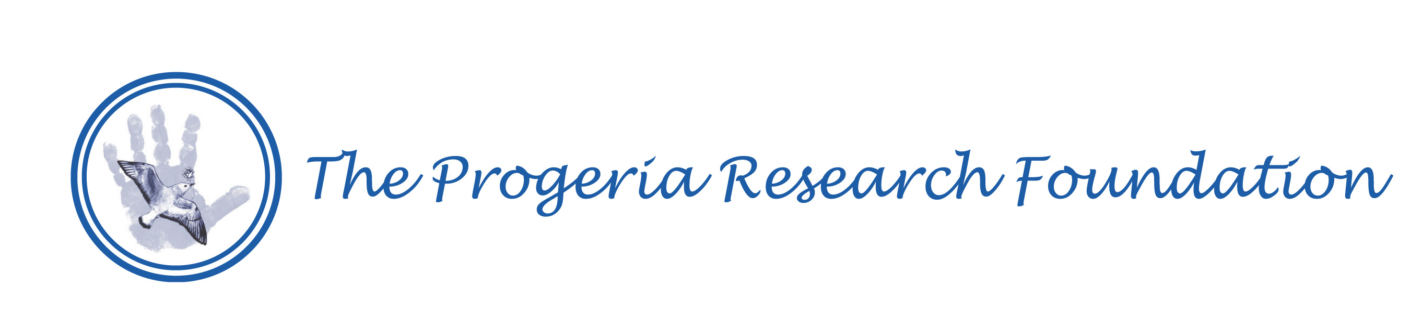

The PRF Cell & Tissue Bank: Description for Potential Participants

The Progeria Research Foundation, Inc. (PRF) holds a cell bank for children affected by Progeria. We have created this bank as a resource for researchers around the world. Blood samples (2-4 teaspoons) or Skin Biopsies or tissue samples from children with Progeria are essential to conducting the research that will explore the cause and potential treatments for Progeria. If you decide to consider donating, we would like you to know the following:

You Will Only Be Asked To Donate One Time: The samples you donate will be made into “cell lines” that will not die. Therefore, donating blood or tissue one time each to the bank will provide enough cells for researchers to study now and in the future. Your samples will be available for researchers throughout the world to any approved research project, rather than only the lab of one researcher.

Privacy and Confidentiality:
PRF established the Cell Bank to make certain that your privacy and confidentiality are protected. We will remove your name and all other identifying information and we will code your samples.

You May Choose to Receive Information on New Discoveries in Progeria:
When new discoveries are made in or new information is published on Progeria, you can choose to be informed. In this way, you will know that your donation has made a difference to Progeria research.

There is No Cost to You or Your Doctors. Here’s how it’s done:
Once you indicate interest, we will begin the informed consent process with you. We will explain the process of sample donation to you completely, with plenty of opportunity for you to ask questions. After you freely consent, we will send you a blood collection or tissue collection kit and instructions. Included is a pre-paid mailer to send the blood or tissue to the laboratory for the PRF Cell Bank.

We can arrange for the samples to be collected by your physician or pediatrician at the next office visit.

Blood can be taken along with other tests such as a lead test, to avoid an extra needle stick.

You may choose to use numbing cream so that there will be little or no pain at the site of the blood draw. There will also be numbing solution for the skin biopsy.

If you are interested in participating, please call 978-535-2594, or e-mail us at info@progeriaresearch.org. Researchers with an interest in donating Progeria cell lines or applying to use material from the bank should also call or write.

Thank you for considering participation in The Progeria Research Foundation Cell and Tissue Bank

Sincerely,
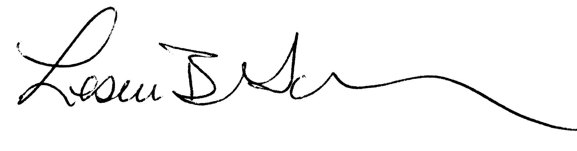
Leslie Gordon , MD, PhD Audrey Gordon, Esq.
Principal Investigator, PRF Medical Director PRF Executive Director

